09/10/2020

CMP4271 Professional Practice for Games Development

Task 2

1. Introduction

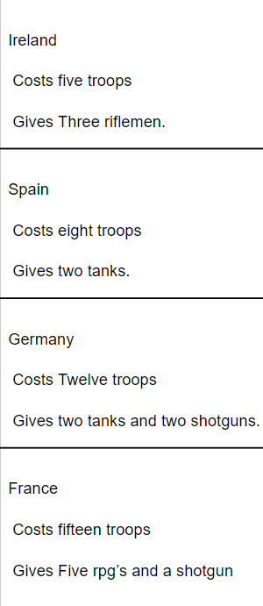The game theme today was Territorial Acquisition. We had to create a game with 2-4 players where we take over territory. Our game is called Monopolisation. We have made it similar to the game Monopoly (<https://www.hasbro.com/common/instruct/00009.pdf>) with the board but not completely. The aim of the game is to land on the tiles to claim land and you win if you have the most territory.

* 1. Materials

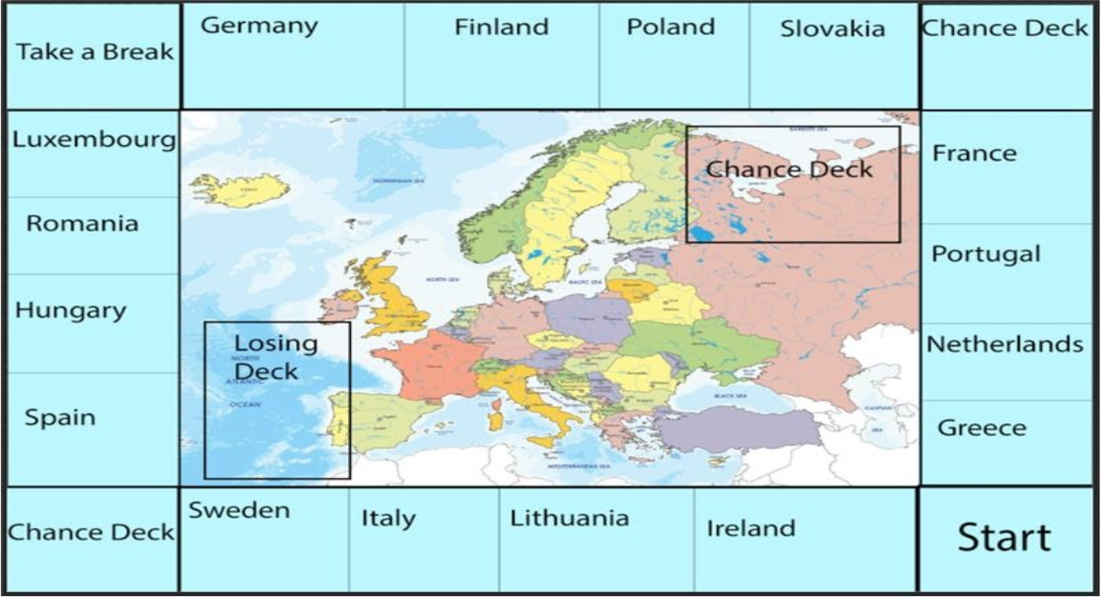

Fig 1 Fig 2

To make the game, you would need the game board (Fig 1), a small object to use as a way to know where you are on the board and the cards that you claim when you buy a territory (Fig 2). You will also need a piece of paper to keep track of how many troops you have.

1.2 Rules

* Players move by rolling a 6-sided dice. If a player rolls a 3, they can move 1, 2, or 3 spaces.
* If you land on an unoccupied tile, you can claim it.
* If you land on an occupied tile, you can choose to battle for that tile.
* If you land on a chance deck, you pick up a card from the chance deck and you could either get a good or a bad card, such as gaining or losing troops.

Battles are fought by using troops.

* The attacking player chooses how many troops they want to put into battle.
* The defender uses their own troops on defence, and they continue to expend troops until one stop.
* Each troop has a value.
* The battle then progresses, and the troops are expended. The winner then keeps the troops they have left over.

1.3 Playtesting

There was no playtesting.

1.4 Discussion

From creating the game, we realised that we would need a way to buy territories, so we decided as a team that we would make each territory cost troops to “guard” each territory and in return, each territory will give you troops during your turn.

The team I had worked with was Danyal Mahmood and Brennon Franklin